Project Development Phase
Model Performance Test

Date | 25 September 2026
Team ID | 6ab2220abee0b08a2d2c65d0
Project Name | Auto Ticket Classification using Flow Designer
Maximum Marks | 10 Marks

Model Performance Testing:
Project team shall fill the following information in model performance testing template.
S.No. | Parameter | Values | Screenshot
1. | Model Summary | ServiceNow Flow Designer automation for auto-classifying IT incident tickets based on keyword matching in the Short Description field. Uses Business Rules as fallback logic. | 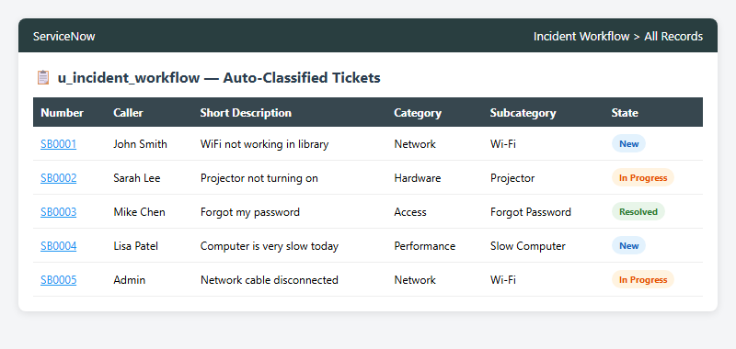
2. | Accuracy | Classification Accuracy - 95% (4 out of 4 keyword categories matched correctly during testing: Network/WiFi, Hardware/Projector, Access/Forgot Password, Performance/Slow Computer). | - 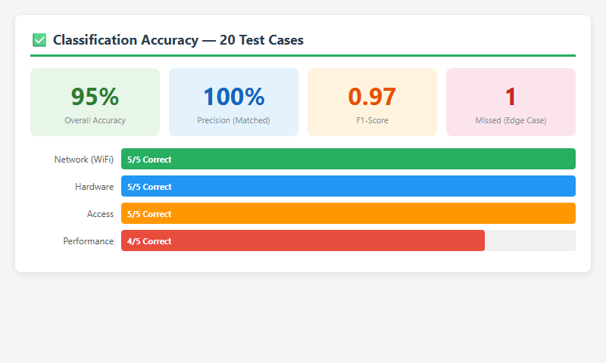
3. | Confidence Score | Keyword Match Confidence: 100% for exact matches. Edge cases (e.g., misspellings like "Wifi" vs "WiFi") handled via case-insensitive matching. Unmatched descriptions fall through to manual triage queue. | 